SCIENCE FAIR BINDER
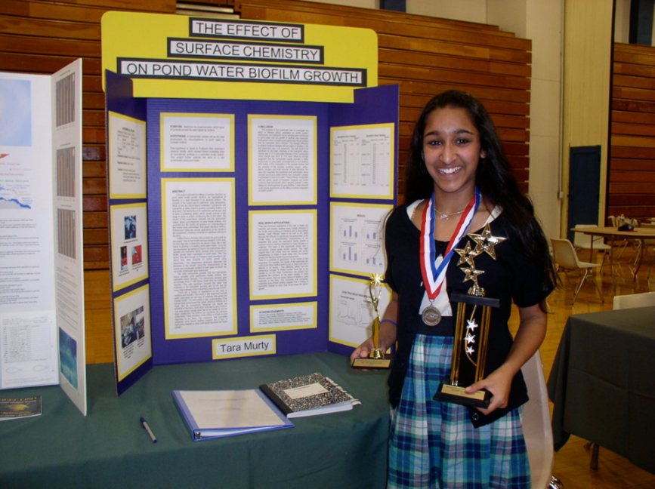
Your binder includes two primary elements:
- Project Journal:

Your journal is a treasured piece of work. Accurate and detailed notes make a logical and winning project. Good notes show consistency and thoroughness to the judges and will help you when writing your research paper. Data tables are also helpful. Your journal may be a little ‘messy’, but be sure the quantitative data recorded is accurate and that units are included in the data tables. Make sure you date each entry. JOURNAL SHOULD BE CLEARLY MARKED WITH YOUR NAME ON FRONT COVER IN DARK INK.

- Project Report:

Your project report is the written record of your entire project from start to finish. This written document is your spokesperson when you are not present to explain your project, but more than that, it documents all of your work. If you have kept a detailed journal, much of the report can be copied from it. Your project report will consist of several sections:

- Title Page and Table of Contents – The title page and table of contents allows the reader to follow the organization of the project report quickly.

- Introduction – The introduction sets the scene for your report. The introduction includes the purpose, your hypothesis, problem or engineering goals, an explanation of what prompted your research, and what you hoped to achieve.

- Materials and Procedures – Describe in detail the methodology you used to collect data, and make observations. Your procedures should be detailed enough so that someone would be able to repeat the experiment from the information presented. Include detailed photographs or drawings of self-designed equipment.

- Data Collected- all the data you collected in table form (OVER)

- Data Analysis and Discussion –
- Any calculations done with the data (such as finding averages, rates of change, etc.) should be shown here.
- Graphs should be presented and discussed.
- What is the strength of relationship between your variables? What trends exist in your data?
- Apply your background research to experimental findings. Did you get the result you expected? Explain.
- Are there other explanations for your results that you had not considered or observed?
- Were there experimental errors in your data taking, experimental design or observations?
- Did experimental results display accuracy and precision? How were your results affected by uncontrolled events?

Remember, understanding errors is a key skill scientists must develop. In addition, reporting that there was no apparent relationship between the variables tested can be valuable information. This is just as much a ‘discovery’ as if there was a relationship between variables

- Conclusion - The conclusion summarizes what you discovered based on your experimental results.
- The conclusion re-states the hypothesis and indicates whether the data supports it. Be specific, do not generalize. Never introduce anything in the conclusion that has not already been discussed.
- Discuss the real world applications of your experimental results. The conclusion can also include a brief description of plans for exploring ideas for future experiments.
- Explain how methods could be improved. What would you do differently if you repeated this project? What other experiments should be conducted?

- Bibliography – should include a minimum of 5 sources

- Science Fair forms – All of your “official” science fair forms and paperwork. If you have human subjects, Informed Consent Forms should be included, as well as any surveys or tests given to subjects.

